**###BeginCaseStudy###**

**Testlet 1**

**Background**

You are developing a video transcoding service. This service is used by customers to upload video files, convert video to other formats, and view the converted files. This service is used by customers all over the world.

**Business Requirements**

The user-facing portion of the application is an ASP.NET MVC application. It provides an interface for administrators to upload video and schedule transcoding. It also enables administrators and users to download the transcoded videos. When videos are uploaded, they are populated with metadata used to identify the video. The video metadata is gathered by only one system when the video upload is complete. Customers require support for Microsoft Internet Explorer 7 and later. The application contains a header that is visible on every page. If the logged-on user is an administrator, then the header will contain links to administrative functions. This information is read from a cookie that is set on the server. The administrative links must not be present if an error condition is present.

**Technical Requirements**

User Experience:

The front-end web application enables a user to view a list of videos. The main view of the application is the web page that displays the list of videos. HTML elements other than the list of videos are changed with every request requiring the page to reload.

Compatibility:

Some customers use browsers that do not support the HTTP DELETE verb. These browsers send a POST request with an HTTP header of X-Delete when the intended action is to delete.

Transcoding:

The video transcoding occurs on a set of Windows Azure worker roles. The transcoding is performed by a third-party command line tool named transcode.exe. When the tool is installed, an Environment variable named transcode contains the path to the utility. A variable named license contains the license key. The license for the transcoding utility requires that it be unregistered when it is not in use. The transcoding utility requires a significant amount of resources. A maximum of 10 instances of the utility can be running at any one time. If an instance of the role cannot process an additional video, it must not prevent any other roles from processing that video. The utility logs errors to a Logs directory under the utilities path. A local Azure directory resource named perf is used to capture performance data.

Development:

Developers must use Microsoft Remote Desktop Protocol (RDP) to view errors generated by the transcode.exe utility. An x509 certificate has been created and distributed to the developers for this purpose. Developers must be able to use only RDP and not any other administrative functions.

Application Structure

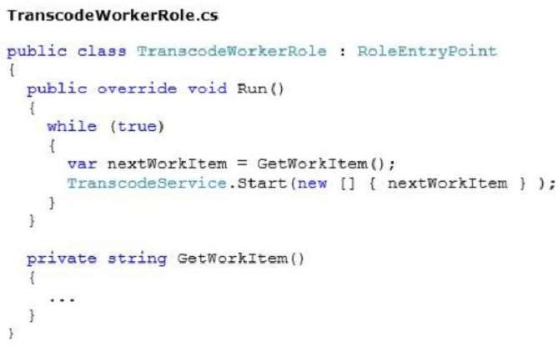

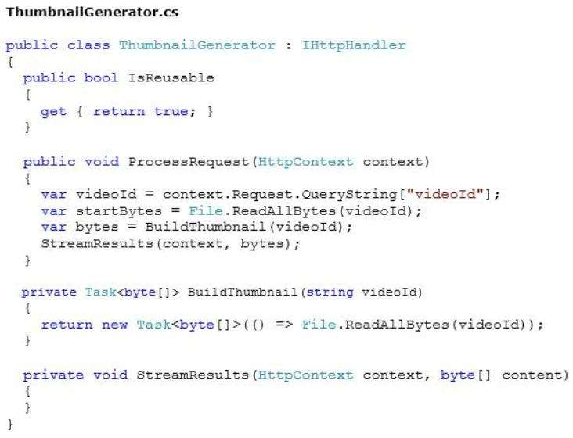

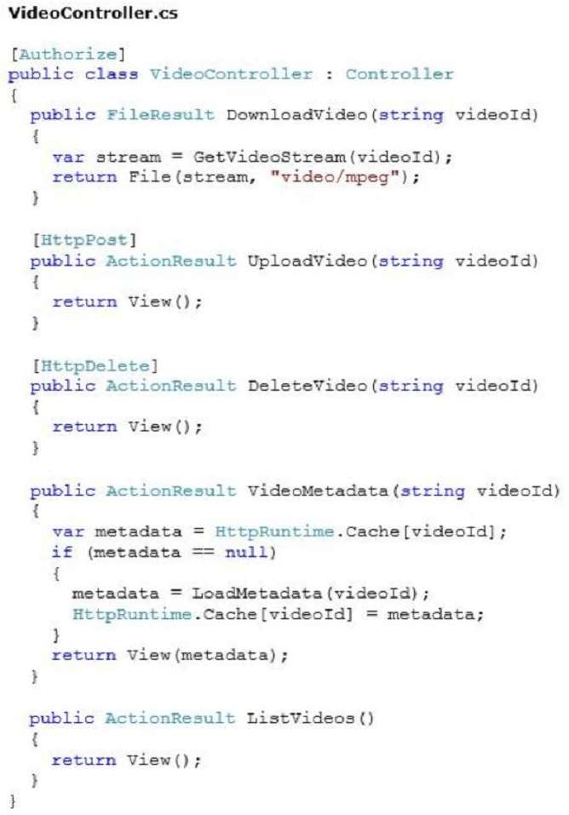

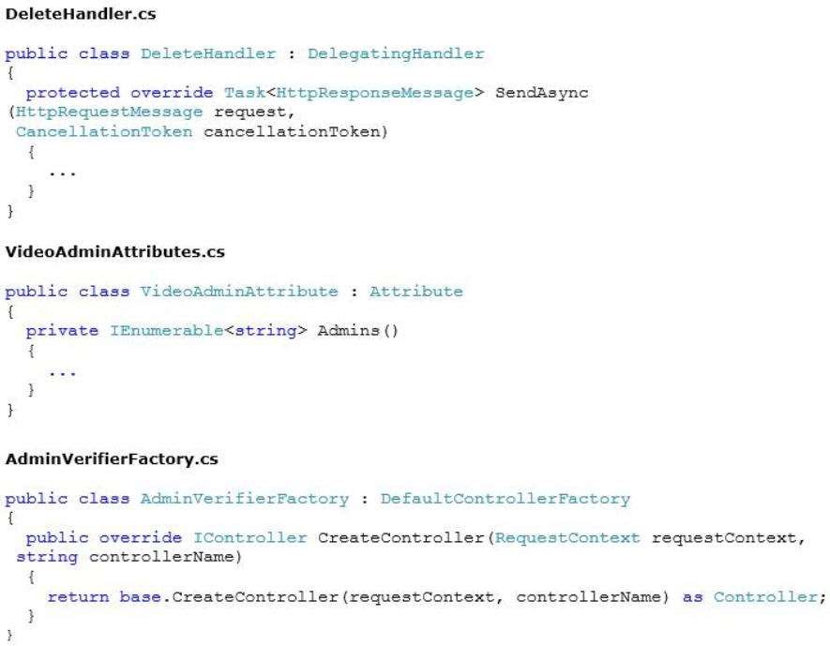

**###EndCaseStudy###**

1. You need to ensure that all the MVC controllers are secure. Which code segment should you use as the body for the CreateController method in AdminVerifierFactory.cs?

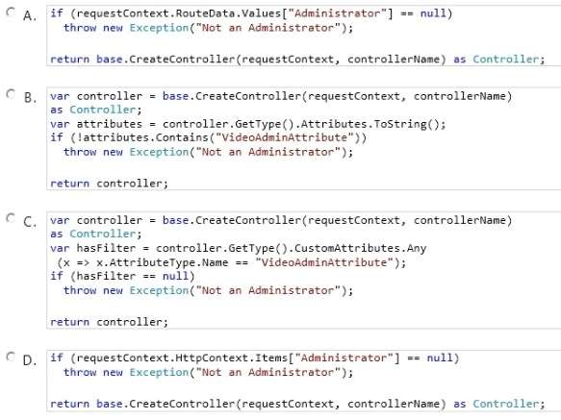

**Answer: C**

1. DRAG DROP

You need to ensure that the transcode.exe utility is installed before the worker role starts. How should you implement the startup task? (To answer, drag the appropriate values to the correct element or attribute. Each value may be used once, more than once, or not at all. You may need to drag the split bar between panes or scroll to view content.)

Select and Place:

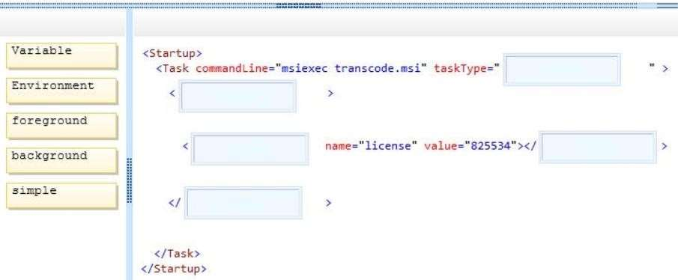

Answer:

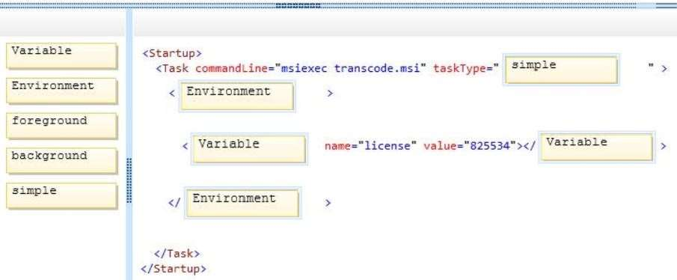

1. You need to ensure that all customers can delete videos regardless of their browser capability. Which code segment should you use as the body of the SendAsync method in the DeleteHandler class?

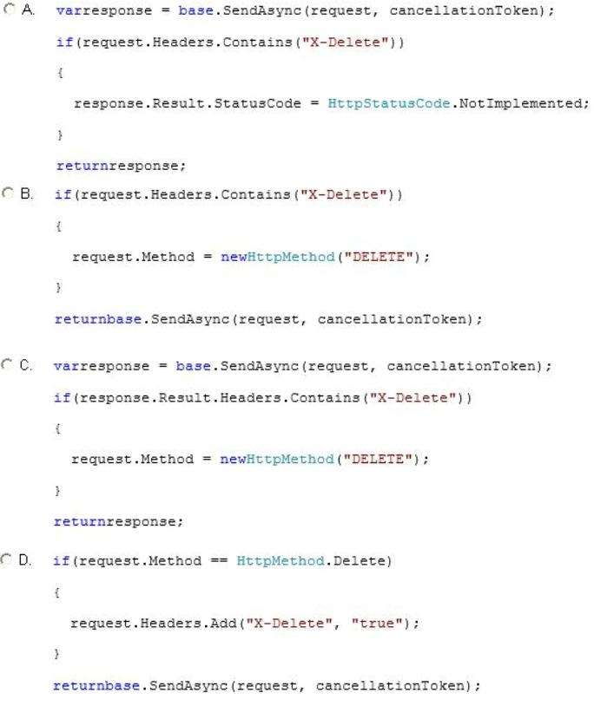

**Answer: B**

1. The transcode.exe utility activates its license online when it is installed. You need to ensure that the registration of the transcode utility is handled as specified in its license. Which method should you add to the TranscodeWorkerRole class?

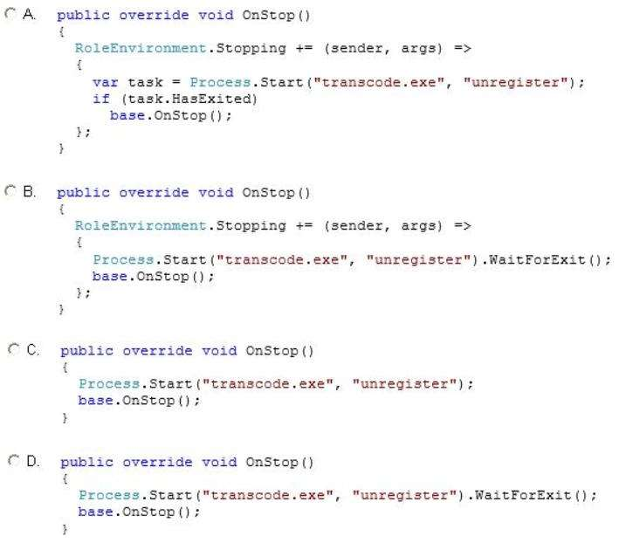

**Answer: D**

1. You need to maximize performance of video delivery. Which code segment should you use as the body of the GetVideoStream function in the Video-Controller class?

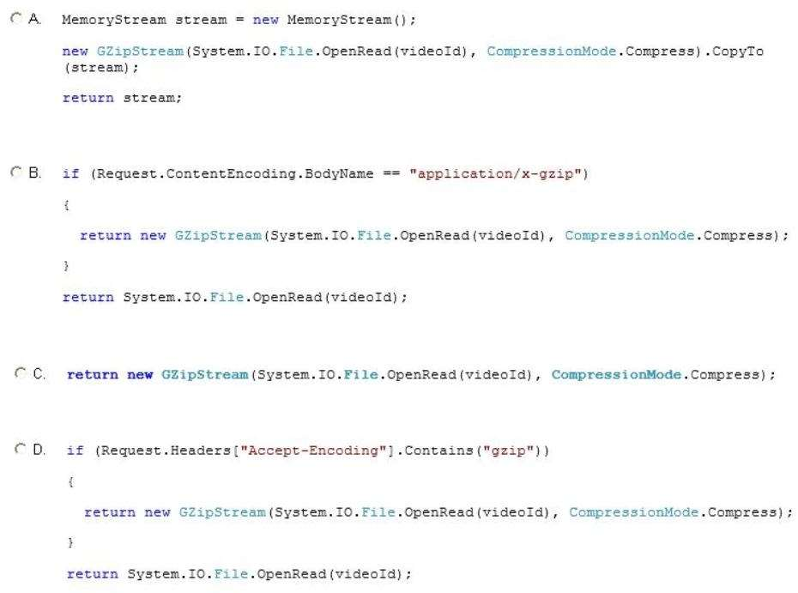

**Answer: D**

1. HOTSPOT

The designer for the website gave you the following image as the design for the page.

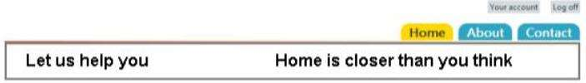

The normal color for the tab is *2da4c2, and the color when the mouse is over the tab is #ffd800. The HTML that implements the navigation tab is as follows.

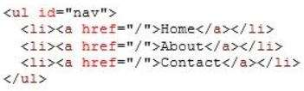

You need to implement the design. What should you do? (To answer, select the appropriate options in the answer area.)

Hot Area:

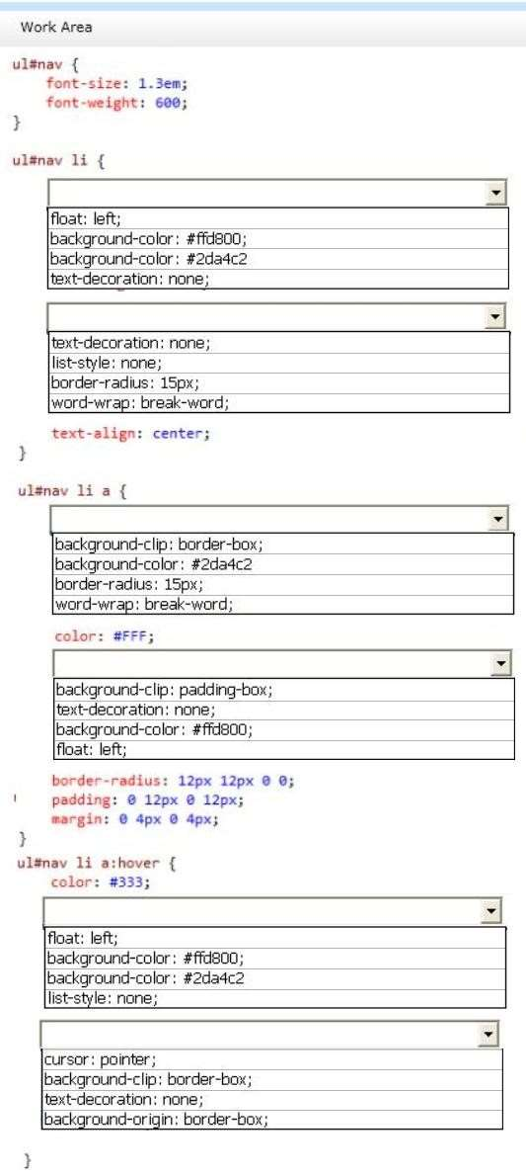

Answer:

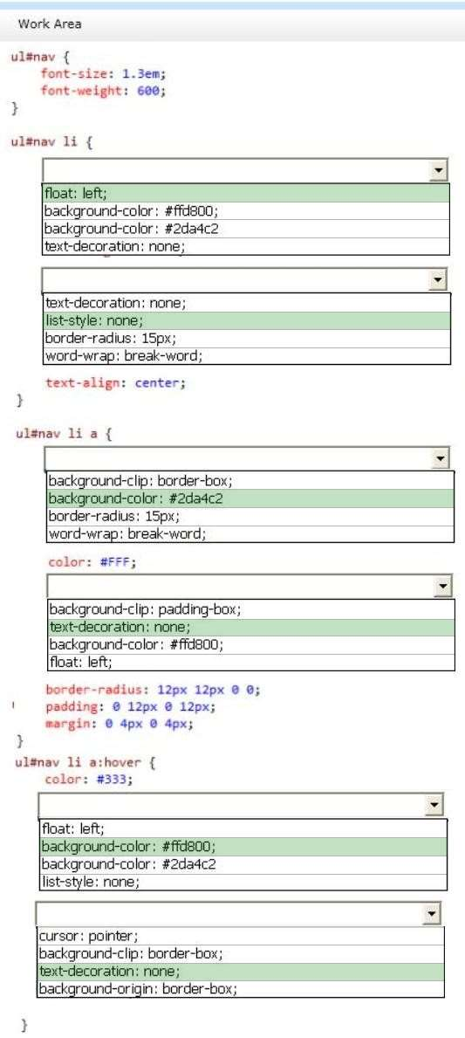

1. You are creating a new authentication system that uses an HTTP header value. The existing authentication system must continue to operate normally. You need to implement the custom authentication. What should you do? (Each correct answer presents a complete solution. Choose all that apply.)
2. Create a class derived from ActionResult and check for a valid HTTP header value in the ExecuteResult method. Change all actions to return this new class.
3. Create an HttpHandler to check for a valid HTTP header value in the ProcessRequest method.
4. **Create an HttpModule and check for a valid HTTP header value in the AuthenticateRequest event.**
5. **Create a class derived from AuthorizeAttribute and check for a valid HTTP header value in the AuthorizeCore method. Change usages of the existing AuthorizeAttribute to use the new class.**
6. Customers download videos by using HTTP clients that support various content encodings. You need to configure caching on the DownloadVideo action to maximize performance. Which attribute should you add?



1. Option A
2. Option B
3. Option C
4. Option D
5. **Option E**
6. You need to ensure that developers can connect to a Windows Azure role by using RDP. What should you do?
7. Export a certificate without a private key. Upload the .cer file to the Management Certificates section on the Azure Management Portal.
8. Export a certificate with a private key. Upload the .pfx file to the Management Certificates section on the Azure Management Portal.
9. Export a certificate without a private key. Upload the .cer file to the Certificates section under the TranscodeWorkerRole hosted service on the Azure Management Portal.
10. **Export a certificate with a private key. Upload the .pfx file to the Certificates section under the TranscodeWorkerRole hosted service on the Azure Management Portal.**